**Objective**:

The objective of the project is to predict the disease – Early Blight or Late Blight based on the image given. It is using CNN and deep learning. It involves data Cleaning and pre processing like data augmentation.

**Outcome**:

Prediction of the disease based on the pictures of the potato plant leaves.

**Tools Used**:

1. Python
2. Tensor flow, Layers for ANN and CNN
3. Matplotlib for data visualization
4. sklearn for model building
5. Jupyter notebook as IDE

**Execution**:

The data is comes from tf dataset.

Model building uses TF, CNN, data augmentation and tf dataset.

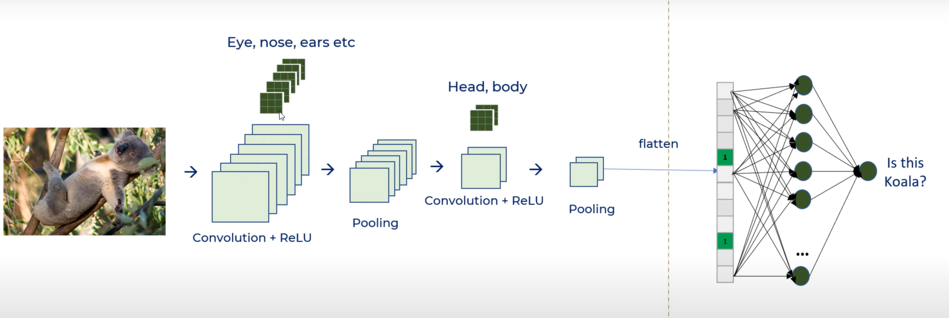

Using the first part we extract the features and in the second part we flatten the dataset to be fed to fully connected Dense Neural Network